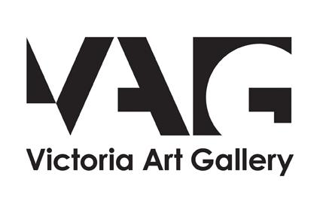

# Accessibility Guide for Victoria Art Gallery

[victoria_enquiries@bathnes.gov.uk](mailto:victoria_enquiries@bathnes.gov.uk), [01225 477233,](tel:01225%20477233) <www.victoriagal.org.uk>

**Contact for accessibility enquiries: victoria_enquiries@bathnes.gov.uk**

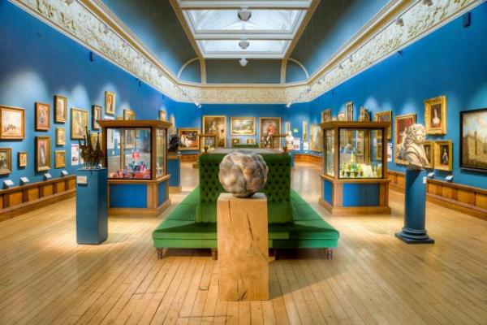

### Welcome

We extend a warm welcome to disabled visitors and others with access needs.

Accessible entrance on Bridge Street opposite Mallory’s jewelers.

The Victoria Art Gallery is located in the centre of Bath. It has been open to the public since the year 1900. The permanent collection is displayed on the first floor and temporary exhibition spaces occupy the ground floor.

The permanent collection includes over 1500 decorative arts treasures, including a display of British oil paintings from 17th century to the present day with work by Thomas Gainsborough, Thomas Jones Barker and Paul Klee.

## At a Glance

### Level Access

* There is level access from the main entrance to:
  + Lower gallery
  + Upper Gallery
  + Unisex accessible toilet
  + Victoria Art Gallery shop
  + Rotunda

### General

* We have a complimentary ticket policy for personal assistants.
* There is at least 1 public toilet for disabled visitors.
* All staff have disability awareness training.

## Getting here

Bridge Street  
Bath  
Somerset  
BA2 4AT

#### Travel by public transport

* You can get to Victoria Art Gallery by bus and train.
* The central bus station is next to the train station, both stations are 0.5 miles / 0.8 km / 0.8 km, a ten-minute walk away from the Victoria Art Gallery. The address is: Southgate Street Bath BA1 1TP The nearest train station is Bath Spa. The train station is 0.50 miles / 0.8 km from Victoria Art Gallery.
* The nearest train station is Bath Spa.   
  The address is:  
  Dorchester Street  
  Bath  
  BA1 1SU

#### Travel by taxi

* You can get a taxi with V Cars by calling 01225 464646. The taxi company has a wheelchair accessible vehicle.
* Find out more about taxis here: https://beta.bathnes.gov.uk/taxi-ranks

#### Parking

* Nearest Blue Badge parking spaces: High Street Bath BA1 5EB. These are outside the Guildhall front entrance. Two spaces to the right of the entrance and two spaces to the left of the entrance. The nearest car park is:  
    
  The Podium  
  9A Walcot St  
  Bath  
  BA1 5BN  
    
  Vehicle entrance and exit from Walcot Street. This has level access to the outside, follow the signs to street exit or through Waitrose.  
  Find out more about public car parks here: https://beta.bathnes.gov.uk/find-car-parks-bath
* Watch the video: [Accessible parking](https://youtu.be/a4Jm2UO40Y4)

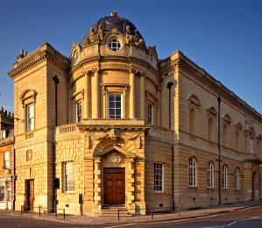  
Exterior of the Victoria Art Gallery

## Arrival

#### Main entrance

* This entrance has a handrail.
* The main door is side hung and manual.
* The other entrance door is 1500.00mm wide.
* The ground and first floors can be accessed via the ramped entrance on Bridge Street.
* - Accessible doors are 150cm wide.  
  - The push pad button is on the left of the door, once pressed, stand well back on the pavement to clear the area as the doors open outward.   
  - Pressing the button will automatically open the door.  
  - All gallery rooms and the unisex accessible toilet can be accessed this way.  
  - The minimum width of the ramped entrance is 150cm or 4ft 11in.

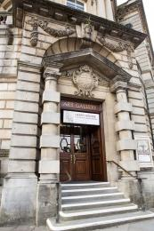  
Door to the main entrance

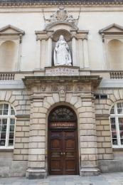  
Accessible entrance on Bridge Street

## Getting around inside

#### Lift

* We have 1 lift.
* You can get a lift to all floors.

#### Lift to all floors

* The lift door is 800mm wide.
* The lift is 1110mm wide. The lift is 1380mm deep.
* The lift door is 80cm wide and the weight limit is 630kg. The lift is 111cm wide and 138cm deep. The entrance foyer by the main doors is accessed only by steps.

#### Ticket/ information desk

#### Reception and ticket sales

* We have a complimentary ticket policy for carers and personal assistants. Disabled visitors pay the standard price for admission, the accompanying carer goes free.   
  Find out more here: [www.victoriagal.org.uk/accessibility](http://www.victoriagal.org.uk/accessibility)

#### Things to See and Do

* We have a complimentary ticket policy for personal assistants.
* Information sheets in five languages

#### Lower gallery

* From the main entrance to this area, there is level access. Some display information is low, for wheelchair users. There are seats.
* The lower gallery can be accessed by the door on Bridge Street.

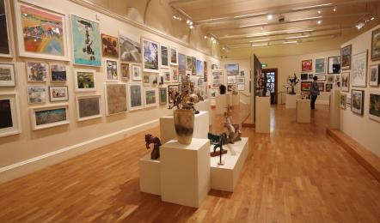  
The large lower gallery where temporary exhibitions are installed

#### Upper Gallery

* From the main entrance to this area, there is level access. There is a lift.
* Some display information is low, for wheelchair users. There are seats.
* The lift access from the ground floor to the Upper Gallery is located next to the ticket desk, press button 1 for first floor.  
  When returning to the ground floor Small Gallery press button 0.

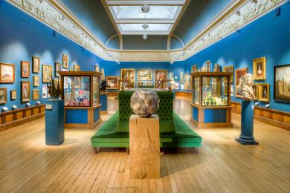  
Upper gallery where the permanent collection is held

#### Public toilet

#### Unisex accessible toilet

* There is a public toilet for disabled visitors.
* From the main entrance to the public toilet, there is level access. There is a lift.
* - There is one unisex public toilet for all visitors with access needs, there are additional toilets for carers if needed.  
  - The toilet has an emergency pull cord and response provided, support rails but limited transfer space, and a basin with mixer lever tap. There are baby changing facilites available.  
  - The nearest Changing Places toilet is SouthGate Bath Shopping Centre, 12 Southgate Street, Bath BA1 1AQ

#### Shop

#### Victoria Art Gallery shop

* From the main entrance to the shop, there is level access. The route through the shop is 800mm wide, or more.
* - Access to the shop is through the accessible entrance on Bridge Street.   
  - There is bright lighting  
  - Many products are displayed at low level. Staff are available to help if required.

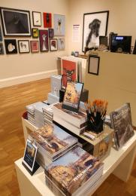  
Products in the shop

#### Rotunda

* From the main entrance to this area, there is level access. There is a lift.
* The rotunda can be accessed by the door on Bridge Street and then by taking the lift to the first floor. You can sit down in this area.

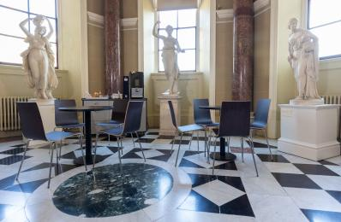  
Seating and tables in the rotunda

## Customer care support

#### Accessibility equipment

* For a list of more items, please go to https://www.victoriagal.org.uk/accessibility.
* Please ask a member of staff on arrival for directions to the nearest toilet area for assistance dogs.
* You can hire mobility equipment from Assured Mobility by calling 01225 831960.

#### Emergency evacuation procedures

* We have emergency evacuation procedures for disabled visitors.
* Evacuation routes are clearly marked and staff are well trained in handling evacuations.

#### Customer care support

* All staff have disability awareness training.
* We have other services for people with accessibility requirements.
* A sign language interpreter can be arranged in advance.

Guide last updated: 17 January 2024